**Chapter 17: PNPN Devices**

Table of Contents

Silicon Controlled Rectifier (SCRs) 3

Silicon Controlled Switches (SCSs) 6

Gate Turn-Off Switch (GTOs) 7

Light-Activated SCRs (LASCRs) 8

DIACs 9

TRIACS 10

PNPN devices are a family of four-layer semi-conductor diodes that include

* Silicon Controlled Rectifiers (SCRs)
* Silicon Controlled Switches (SCSs)
* Gate Turn-Off Switches (GTOs)
* Light Activated SCRs (LASCRs)
* DIACS
* TRIACS

These four-layer devices are commonly called thyristors, although the term usually refers to SCRs specifically.

## Silicon Controlled Rectifier (SCRs)

An SCR is a switching device for high-voltage and high-current operations. Like an ordinary rectifier, an SCR conducts in one direction, and has three terminals, the anode, the cathode and the gate.

 

Like a normal rectifier, the anode must be forward biased and the cathode must be reverse biased so that current can flow from the anode to the cathode. The central junction must also be forward biased. This is where the gate helps us. In this case, to make the central junction forward biased, the gate must be given a positive voltage.

A more detailed diagram of the SCR is given below. We can see that it is a combination of a PNP transistor and an NPN transistor.

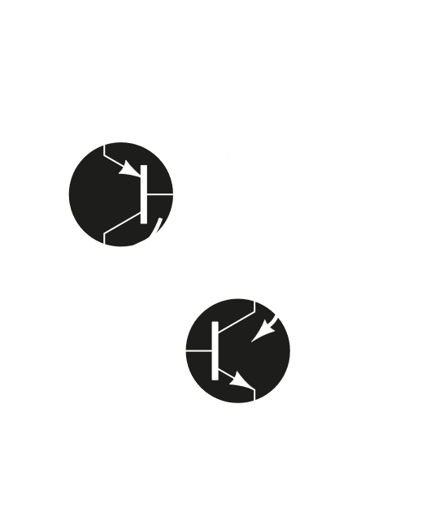

Thus, if we apply a positive charge to the gate, it becomes forward biased. The carrier flow from acts as a base for , which in turn allows current to flow through . This increases the base current for , which increases the base current for and so on.

We can see that the gate is responsible for controlling the device. Current will only flow once we apply a positive voltage to the gate, so we can use this ability to control which part of a signal will be allowed to pass, meaning we can control the phase.

Note that a negative signal cannot pass through an SCR. This means the device will essentially be switched off if we reverse the signal, or even if we remove it. You would imagine giving the gate a 0 voltage would also do the same, but once current flow has started just switching the gate off will not be enough to switch off the device. If we want to use the gate to stop the device, we have to apply a negative voltage of the same magnitude as the positive voltage we applied to start the device. A third method would be to simply put a switching circuit parallel to the device which creates a short circuit, switching it off. This is called commutation circuitry.

The characteristics of an SCR should be easy to understand now.

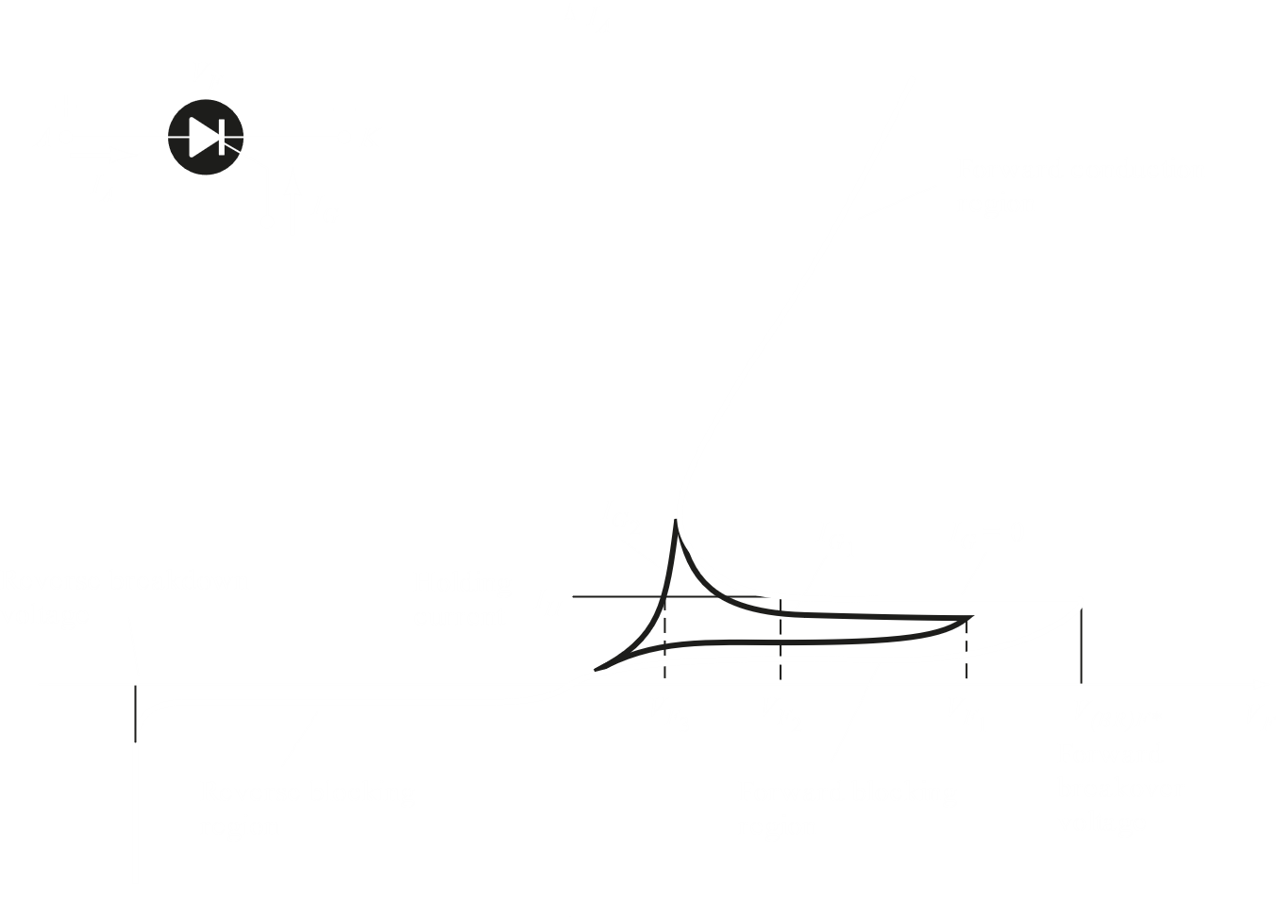

Notice that there is always a forward and backward breakdown voltage that essentially will allow current to pass even if a gate voltage is not applied, exactly like normal transistors. An SCR can be forced to trigger if there is an excessively high voltage from anode to cathode, a high frequency signal from gate to cathode or a high operating temperature.

Increasing the gate voltage reduces the forward breakdown voltage. What this also means is that the greater the voltage we apply to the gate, the lower the voltage across the anode and cathode must be to achieve the same level of conduction.

Applications of SCRs include as battery-charging regulators, in temperature controller circuits or emergency-lighting systems.

## Silicon Controlled Switches (SCSs)

In a silicon-controlled switch, there are two gates, one at the cathode and one at the anode. Either gate can be used to fire the SCS, meaning both positive and negative signals are acceptable. Either gate can also switch off the SCS by applying the required opposite voltage. Note that the anode gate requires higher voltages than the cathode gate.

 

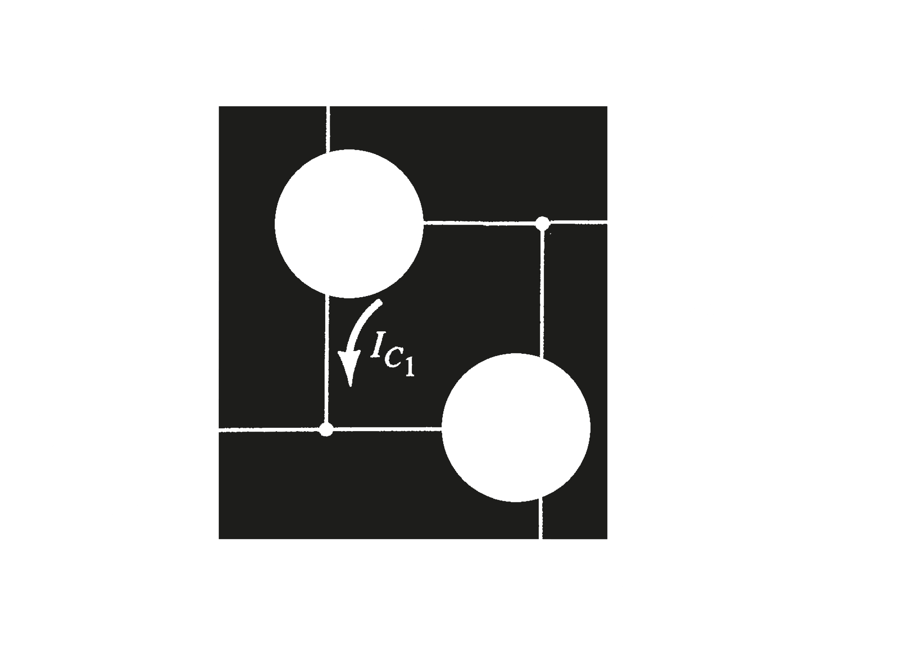

SCSs have much lower power capabilities compared to SCRs and also have faster switching times.

## Gate Turn-Off Switch (GTOs)

Gate turn-off switches are similar to SCRs, except that the gate can turn the GTO on and off.

 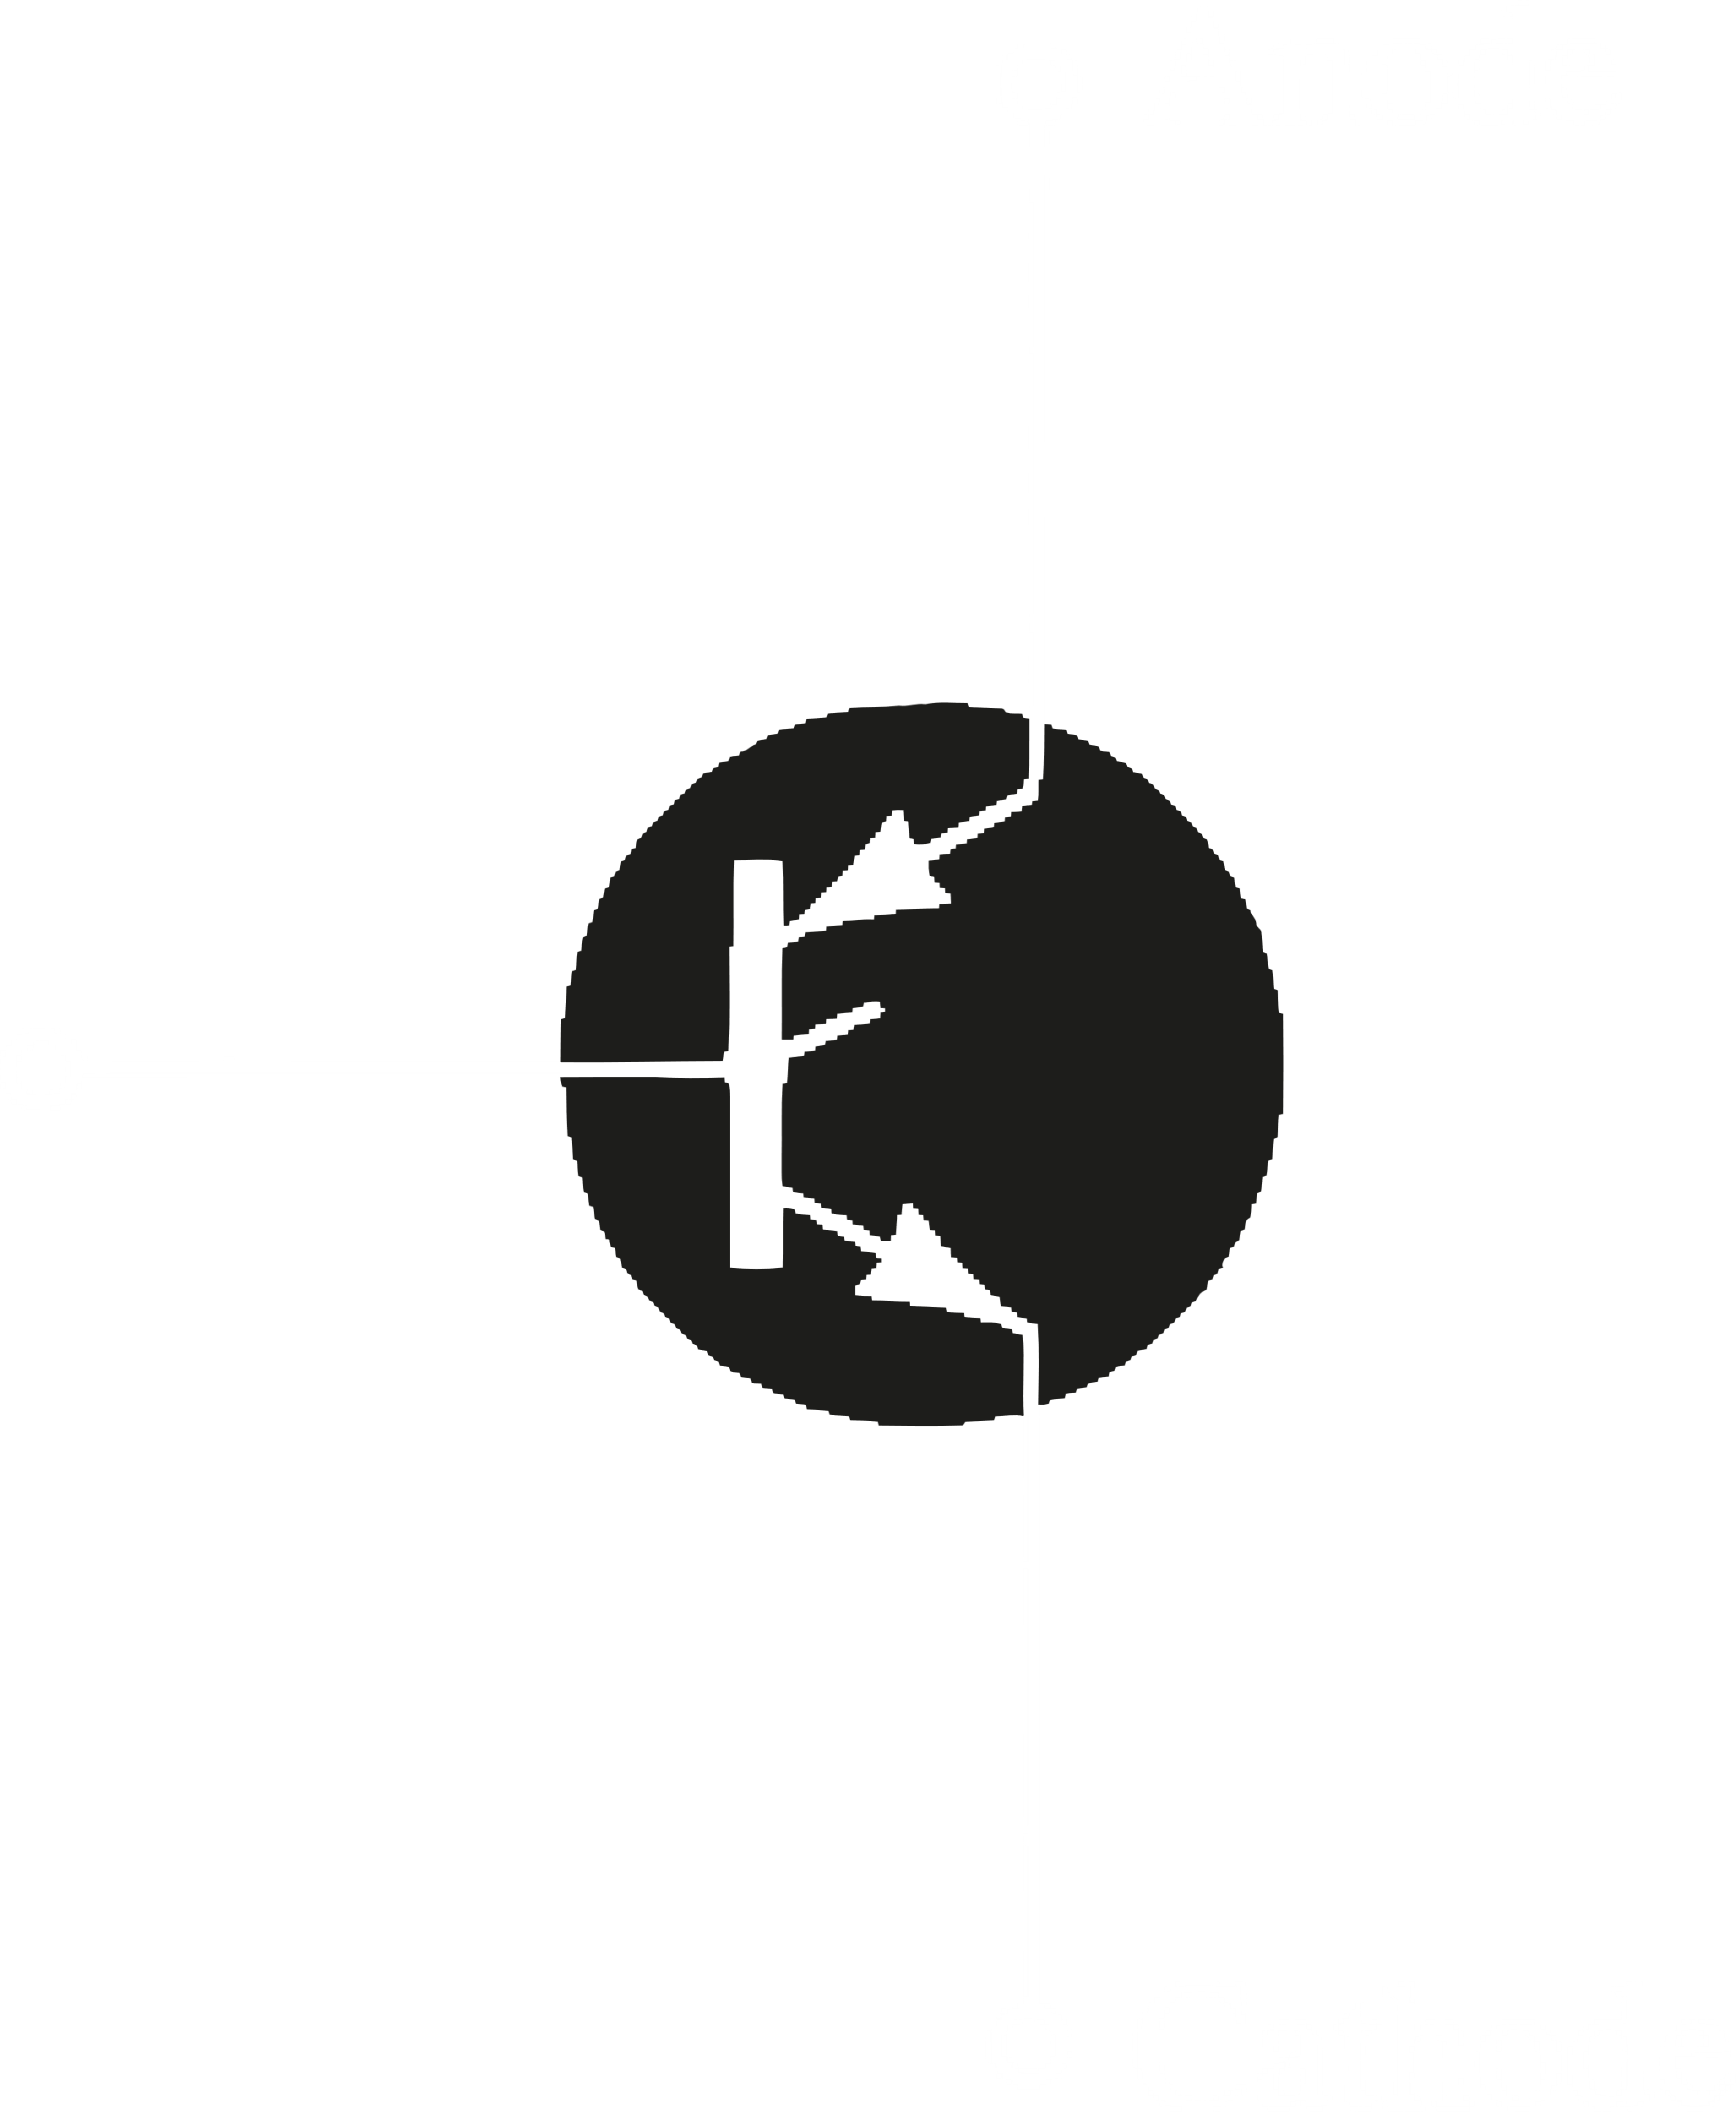

## Light-Activated SCRs (LASCRs)

A light-activated SCR is made of a special material such that the gate is activated when light falls on it.

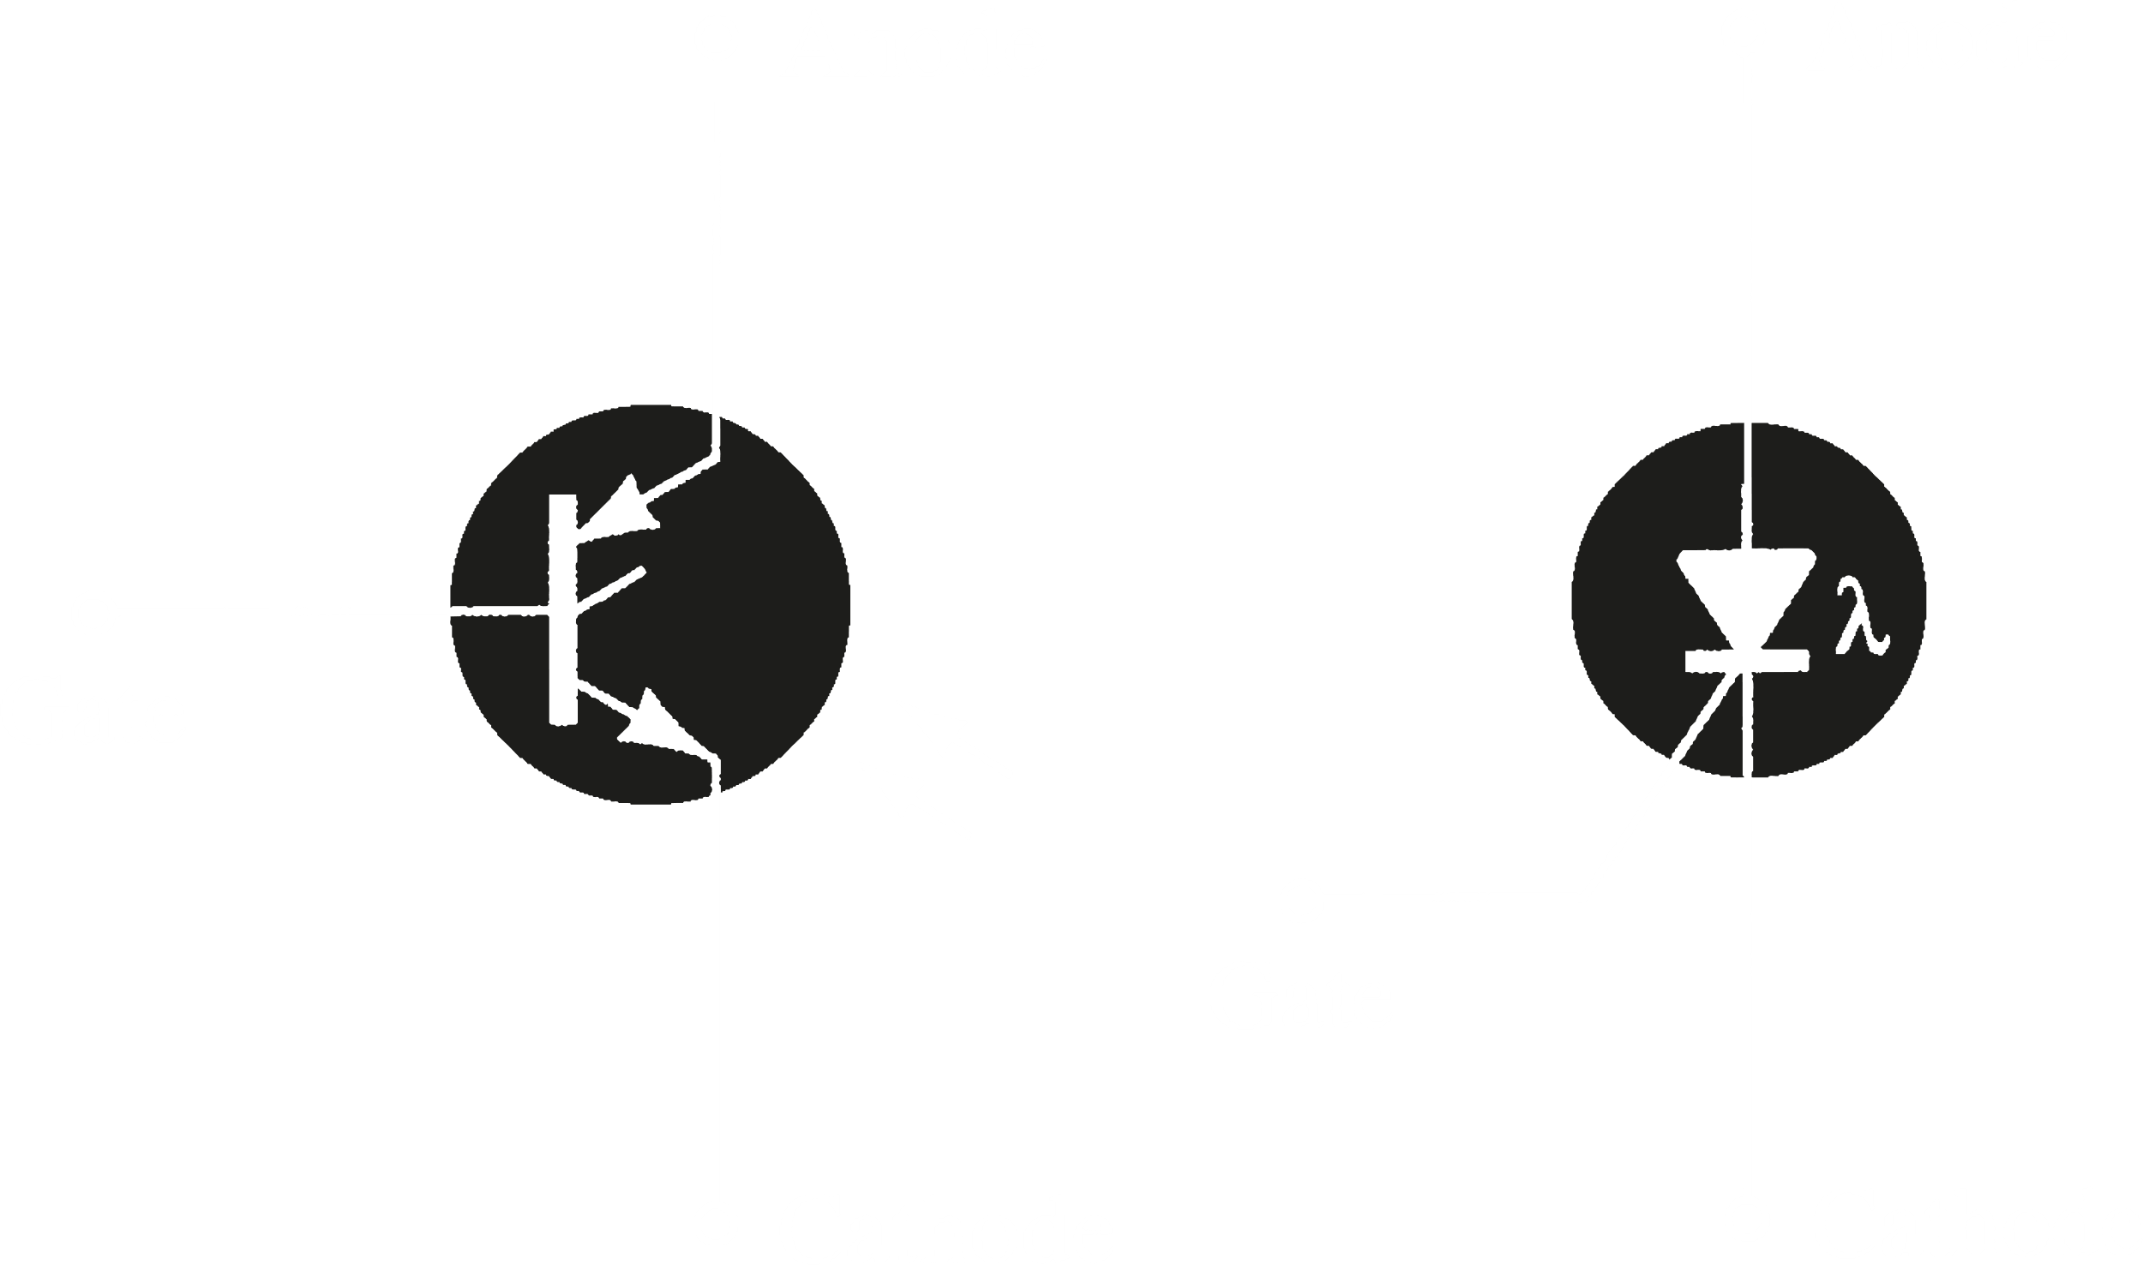

## DIACs

DIACs are double ended SCRs. Essentially, it deals with the reverse side of the SCR’s characteristics. It does not have a cathode, but has two anodes. We can now transmit both positive and negative signals.

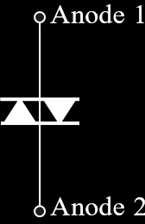 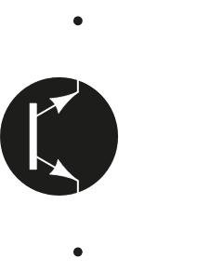 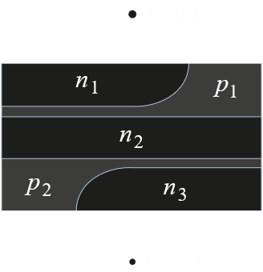

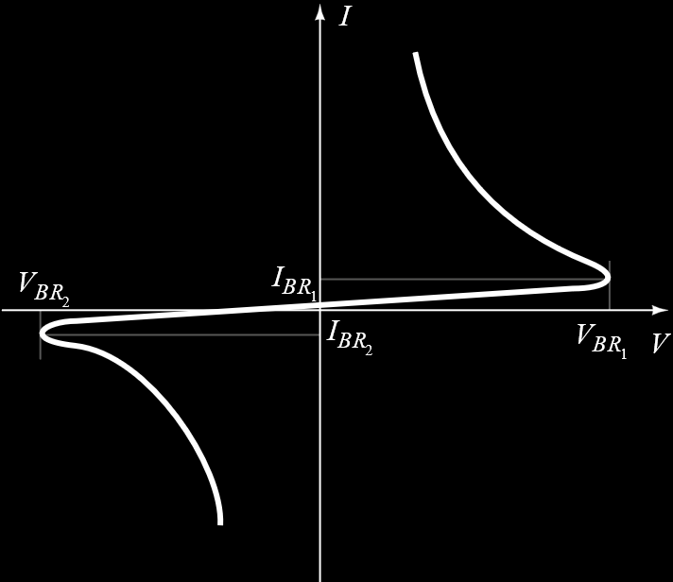

## TRIACS

TRIACs are similar to DIACS, except that it has a gate and can thus be controlled.

